HOME LAB INFRASTRUCTURE
& CI/CD PORTFOLIO
PROJECT DOCUMENTATION | 01 - 04
Implementation Report
Active Directory, Domain Client, File Server Access Control, and Automated CI/CD with Monitoring
Prepared by | Muhammad Danu Susyanto
Portfolio Focus | IT Infrastructure / IT Support / DevOps
Environment | Proxmox Home Lab - danu-lab.local
Document Status | Final implementation documentation - Projects 01 to 04

DOCUMENT OVERVIEW

Executive Summary
This document records the implementation of four progressive home lab projects designed to demonstrate hands-on capability in Windows infrastructure, Active Directory, endpoint administration, file-server access control, CI/CD automation, containerization, security scanning, reverse proxying, and application monitoring.
The projects were intentionally built as a connected environment. Project 01 establishes the identity and DNS foundation. Project 02 validates client integration into the domain. Project 03 applies group-based authorization to a Windows file server. Project 04 extends the lab into a modern delivery platform using Jenkins, Docker, Trivy, Nginx, internal DNS, and Uptime Kuma.
Portfolio Positioning
The combined work demonstrates both classic IT infrastructure administration and DevOps-lite operational practices. The focus is not merely installation, but implementation, validation, failure testing, access control, recovery, and monitoring.

Project Scope Summary
Project | Title | Primary Capability
Project 01 | Active Directory Setup | Identity, DNS, OU design, users, groups
Project 02 | Windows Client Join Domain | Domain integration, DNS, authentication validation
Project 03 | Department-Based File Server Access Control | SMB shares, NTFS ACLs, AD group authorization
Project 04 | Automated CI/CD and Application Monitoring | Jenkins, dynamic agents, Docker, Trivy, rollback, Nginx, Uptime Kuma

Home Lab Environment
Main Network | 192.168.88.0/24
Gateway / Router | 192.168.88.1
Proxmox Host | 192.168.88.10
Windows Server | 192.168.88.20 - AD DS and DNS
Windows Client | WIN-CLIENT-01 - domain-joined endpoint
Ubuntu CI/CD Server | 192.168.88.40 - Jenkins, Docker, Nginx, Uptime Kuma
Internal Domain | danu-lab.local

Logical Environment
192.168.88.0/24
│
├── 192.168.88.1 Gateway / Router
├── 192.168.88.10 Proxmox Host
├── 192.168.88.20 Windows Server 2022
│ AD DS + DNS + File Server
├── WIN-CLIENT-01 Windows 10 Pro Domain Client
└── 192.168.88.40 Ubuntu CI/CD Server
Jenkins + Docker + Nginx + Uptime Kuma

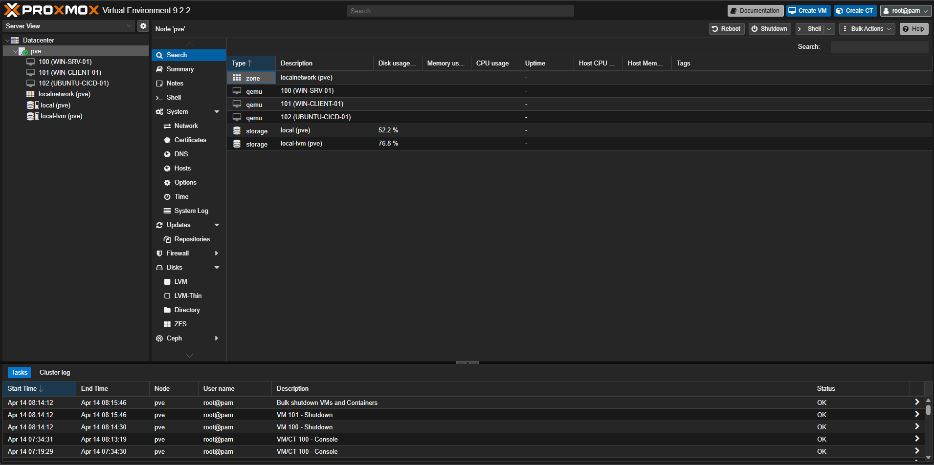
Figure 1. Proxmox Home Lab Overview

PROJECT 01

Active Directory Setup
Objective: build a centralized identity and name-resolution foundation for the home lab using Windows Server 2022, Active Directory Domain Services, and DNS.

What Was Implemented
- Windows Server 2022 virtual machine deployed on Proxmox.
- Static IPv4 configuration with server address 192.168.88.20.
- Active Directory Domain Services role installed and the server promoted to a domain controller.
- New forest and internal domain created: danu-lab.local.
- DNS role integrated with Active Directory and validated through domain name resolution.
- Organizational Unit structure created to separate Computers, Groups, and Users by department.
- Department security groups created: GG_FINANCE, GG_GENERAL, GG_HR, and GG_IT.
- Test user accounts created for Finance, General, HR, and IT departments.
- Users assigned to matching AD security groups.
- Domain authentication and DNS resolution validated from the domain controller.

Core Configuration
Server VM | WIN-SRV-01
Actual Hostname / FQDN | WIN-R5UCS25L8J0 / WIN-R5UCS25L8J0.danu-lab.local
Server IP | 192.168.88.20
Domain | danu-lab.local
NetBIOS Name | DANU-LAB
Primary Roles | Active Directory Domain Services and DNS Server

OU and Identity Structure
DANU-LAB
├── Computers
├── Groups
└── Users
├── Finance
├── General
├── HR
└── IT
User | Department | Security Group
Finance User1 | Finance | GG_FINANCE
gen.user1 | General | GG_GENERAL
hr.user1 | HR | GG_HR
it.admin1 | IT | GG_IT

Validation Performed
- Domain logon validation: whoami returned danu-lab\administrator.
- DNS validation: nslookup danu-lab.local resolved to 192.168.88.20.
- AD Users and Computers reviewed to confirm OU, user, and group placement.

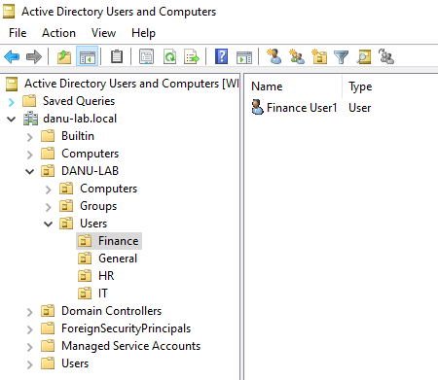
Figure 2. Active Directory Domain and OU Structure

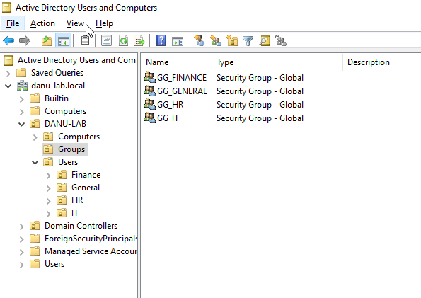
Figure 3. AD Users and Security Groups

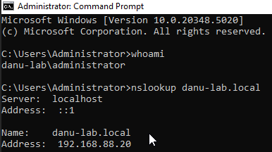
Figure 4. Domain administrator and DNS

Skills Demonstrated
- Windows Server administration
- Active Directory domain design
- OU and group organization
- DNS configuration and troubleshooting
- Identity and access foundation
- Command-line validation

PROJECT 02

Windows Client Join Domain
Objective: integrate a Windows 10 Pro endpoint into the danu-lab.local domain and validate centralized authentication using a standard departmental user account.

What Was Implemented
- Windows 10 Pro virtual machine created on Proxmox as WIN-CLIENT-01.
- VirtIO storage driver loaded during Windows installation.
- VirtIO guest tools installed for optimized virtual hardware support.
- Local administrator account created for initial endpoint administration.
- Computer renamed to WIN-CLIENT-01.
- Client DNS configured to use the Windows DNS server at 192.168.88.20.
- Endpoint joined to the danu-lab.local Active Directory domain.
- Domain login tested using danu-lab\Finance User1.
- Domain identity validated through the whoami command.

Client VM Configuration
VM Name | WIN-CLIENT-01
Operating System | Windows 10 Pro
Virtual Disk | 25 GiB SCSI on local-lvm
CPU / Memory | 2 vCPU / 2 GB RAM
Network | vmbr0 with VirtIO adapter
DNS Server | 192.168.88.20
Domain | danu-lab.local

Domain Join Flow
Configure DNS → Rename Client → Join danu-lab.local → Restart
→ Select Other User → Log in as danu-lab\Finance User1 → Validate identity

Validation Performed
- Domain join completed successfully using a domain administrator credential.
- User danu-lab\Finance User1 authenticated on WIN-CLIENT-01.
- whoami returned danu-lab\Finance User1, proving domain authentication was active.

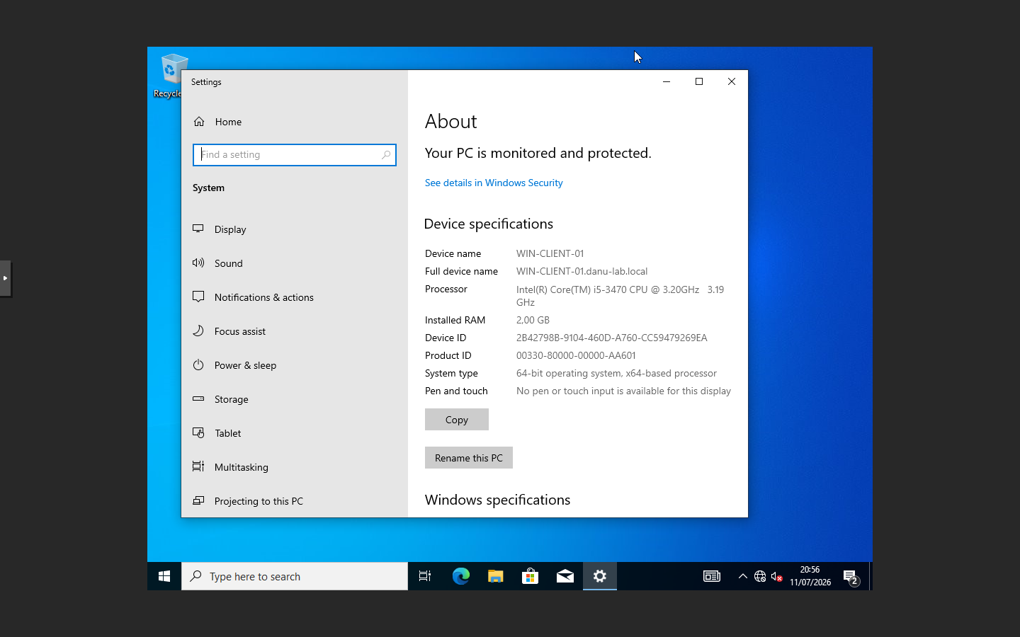
Figure 5. WIN-CLIENT-01 Domain Membership

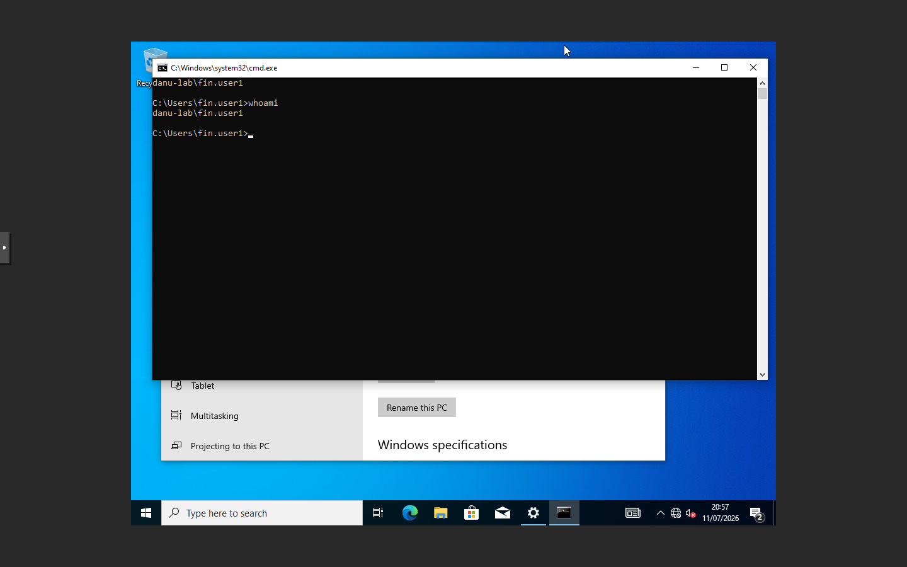
Figure 6. Domain User Login Validation

Skills Demonstrated
- Windows endpoint deployment
- Virtual hardware driver installation
- Client DNS configuration
- Active Directory domain join
- Domain user authentication
- Endpoint troubleshooting and validation

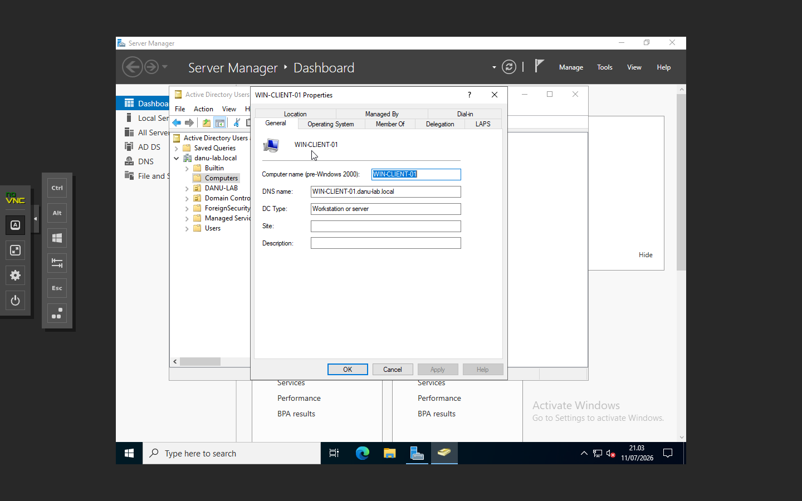
Figure 7. Windows Client in Active Directory

PROJECT 03

Windows File Server with Department-Based Access Control
Objective: implement a Windows file server that uses Active Directory security groups and NTFS permissions to enforce department-based access control.

What Was Implemented
- Department share folders created under C:\Shares.
- Separate SMB shares created for Finance, HR, IT, and Public access.
- Share permissions kept broad while NTFS permissions were used as the primary authorization layer.
- Department security groups from Project 01 reused for folder access control.
- Finance, HR, and IT shares restricted to their matching departmental security groups.
- Public share granted Modify permission to Domain Users.
- Access tested from the domain-joined Windows client using Finance User1.
- Positive and negative access tests performed to prove authorization boundaries.

Share Structure
C:\Shares
├── Finance
├── HR
├── IT
└── Public

NTFS Access Control Design
Folder | Authorized Principal | Access | Purpose
Finance | GG_FINANCE | Modify | Department members only
HR | GG_HR | Modify | Department members only
IT | GG_IT | Modify | Department members only
Public | Domain Users | Modify | All authenticated domain users
Permission Model
SYSTEM and Administrators retain Full Control. Departmental groups receive Modify permission. Share permissions are broad, while NTFS ACLs enforce the effective business access rules.

Validation Performed
- Finance User1 successfully opened \\WIN-R5UCS25L8J0\Finance.
- Finance User1 was denied access to \\WIN-R5UCS25L8J0\HR.
- The result confirmed that AD group membership controlled access through NTFS ACLs.

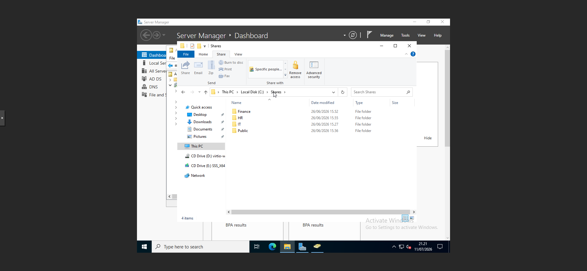
Figure 8. Department Share Folder Structure

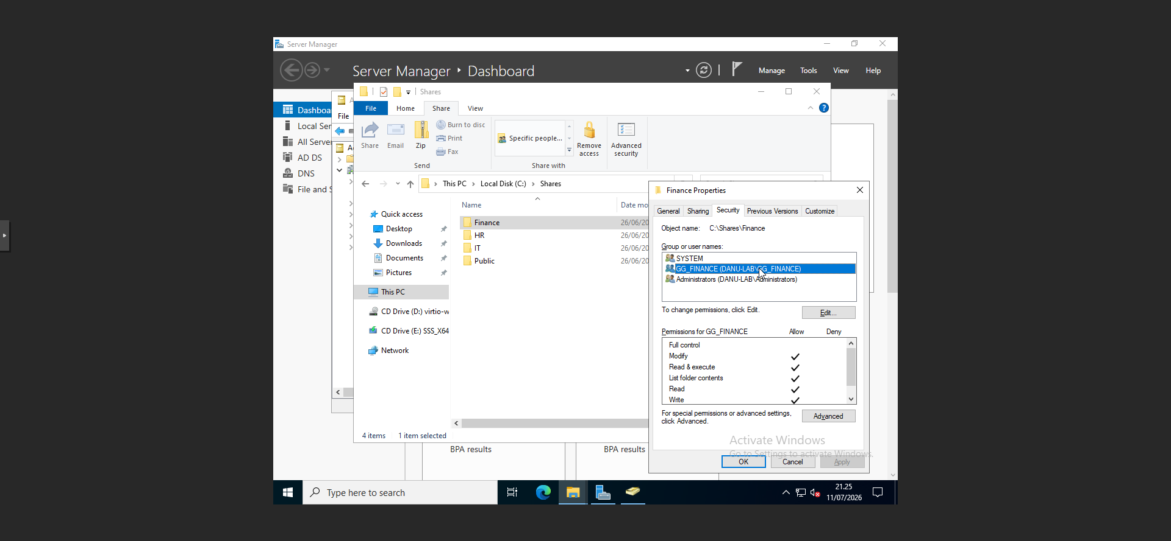
Figure 9. Finance NTFS Permissions

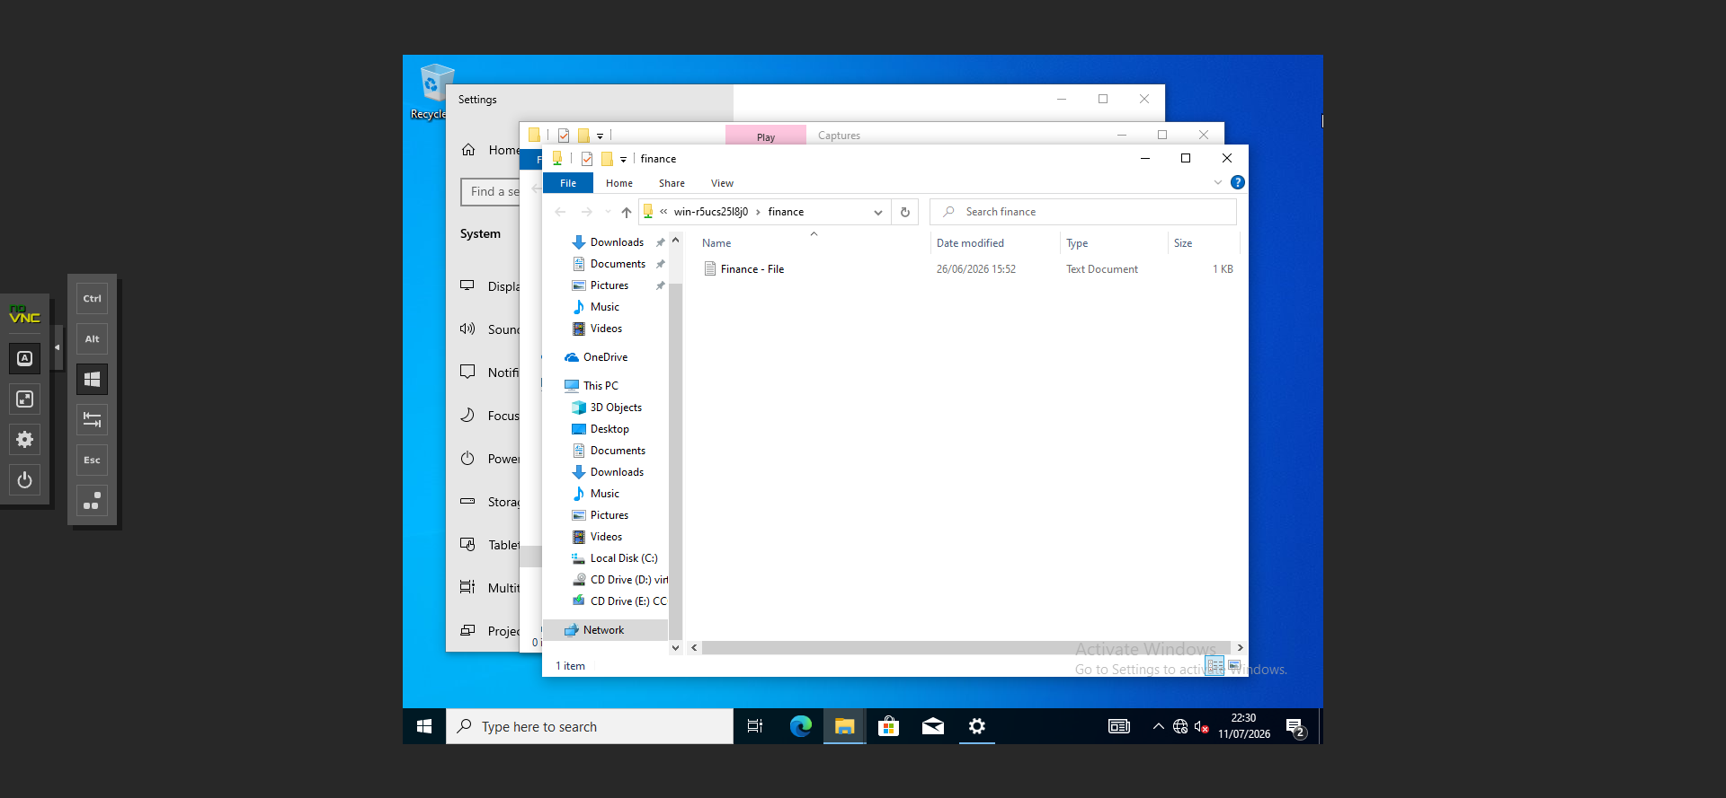
Figure 10. Authorized Access Test

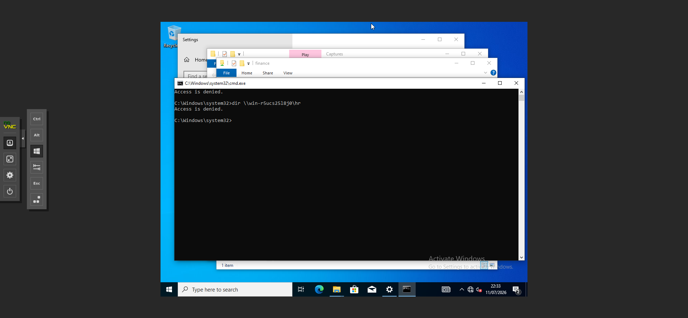
Figure 11. Unauthorized Access Denied Test

Skills Demonstrated
- Windows file-server administration
- SMB sharing
- NTFS ACL design
- Active Directory group-based authorization
- Principle of least privilege
- Positive and negative access testing

PROJECT 04

Automated CI/CD and Application Monitoring Pipeline
Objective: design and implement a practical CI/CD and observability platform for a Nuxt portfolio application using Jenkins, disposable Docker agents, Docker image versioning, Trivy security scanning, automatic rollback, Nginx reverse proxying, internal DNS, and Uptime Kuma monitoring.

Final Architecture
Developer Push
↓
GitHub Private Repository
↓
Jenkins Controller
↓
Dynamic Disposable Docker Agent
↓
Checkout → Build → Trivy Scan → Security Gate
↓
Versioned Docker Image
↓
Deploy → Health Check
├── SUCCESS → Production
└── FAILED → Automatic Rollback → Previous Healthy Image
Client → Internal DNS → Nginx :80 → Nuxt 127.0.0.1:3000
Uptime Kuma → Monitors Nginx-to-Nuxt HTTP endpoint

Ubuntu CI/CD Server
VM Name | UBUNTU-CICD-01
Operating System | Ubuntu Server 26.04 LTS
Hostname | ubuntu-cicd-01
IP Address | 192.168.88.40/24
Gateway | 192.168.88.1
DNS | 192.168.88.20 and external resolver during installation
Storage | Expanded from 20 GB to 40 GB using growpart, pvresize, and lvextend
Core Services | Jenkins, Docker, Nginx, Uptime Kuma

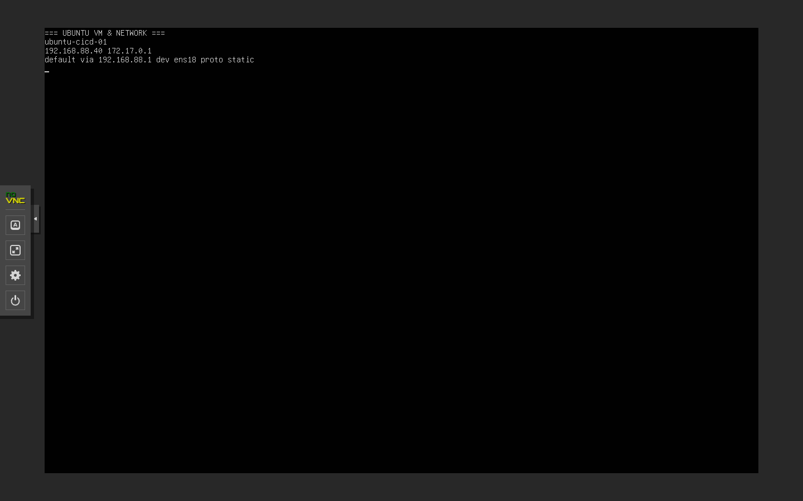
Figure 12. UBUNTU-CICD-01 VM and Network

Jenkins Controller and Dynamic Docker Agents
- Jenkins installed natively as a systemd service on Ubuntu.
- OpenJDK 21 runtime installed for Jenkins.
- Jenkins Docker Plugin configured with local Docker Engine over unix:///var/run/docker.sock.
- Cloud configuration created as local-docker with container cap of 2.
- Dynamic agent template labeled docker-agent created for pipeline workloads.
- JNLP inbound agent connection used with fixed TCP port 50000.
- Custom agent image built from jenkins/inbound-agent:latest-alpine-jdk21.
- Agent image extended with Git, curl, Docker CLI, Docker Compose CLI, OpenSSH client, and Bash.
- Host Docker socket mounted into disposable agents using Docker-outside-of-Docker.
- Docker group GID 107 supplied as an extra group to allow socket access.
- Agent containers automatically removed after pipeline completion.

Custom Jenkins Agent Image
FROM jenkins/inbound-agent:latest-alpine-jdk21
USER root
RUN apk add --no-cache \
git \
curl \
docker-cli \
docker-cli-compose \
openssh-client-default \
bash
USER jenkins

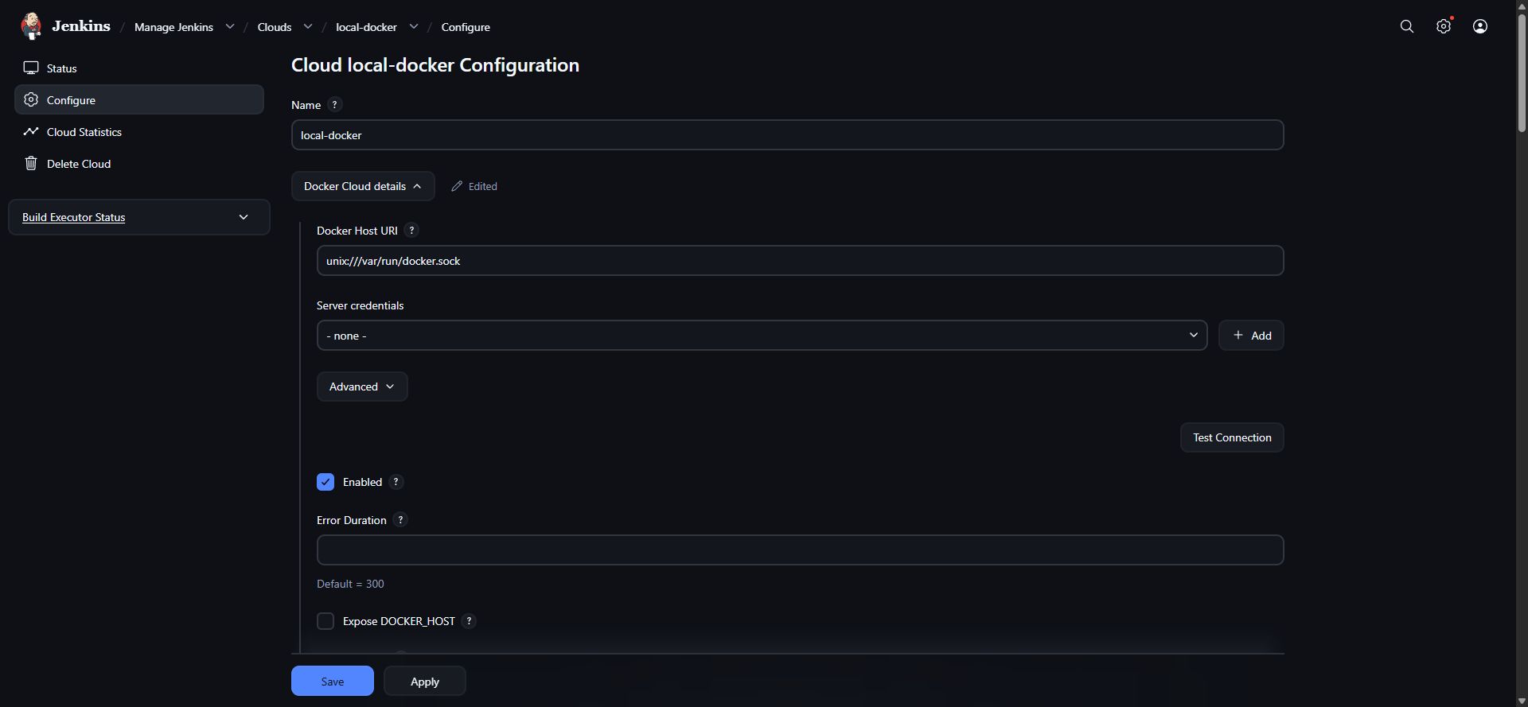
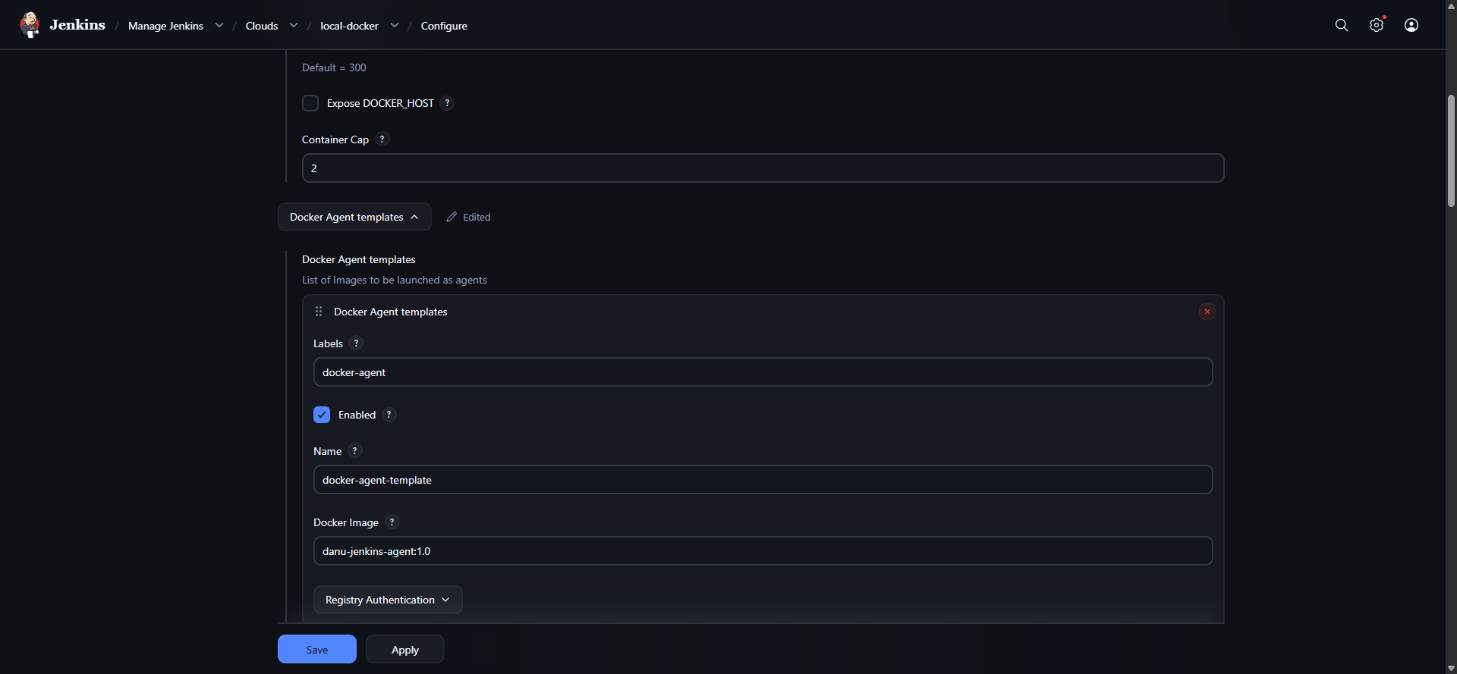
Figure 13. Jenkins Docker Cloud and Agent Template

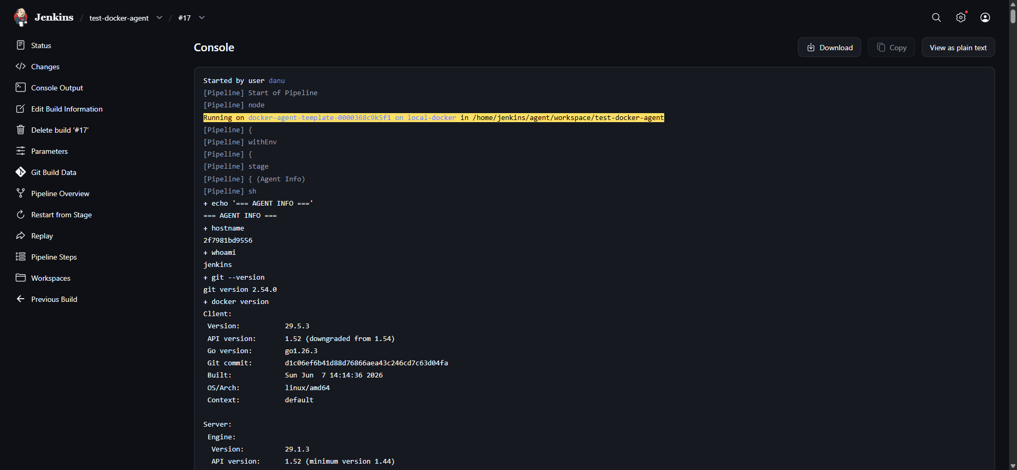
Figure 14. Disposable Docker Agent Validation

Private GitHub Repository and SSH Authentication
- Nuxt portfolio source hosted in a private GitHub repository.
- Repository access configured through a read-only GitHub Deploy Key.
- Separate Jenkins SSH key created for CI/CD access.
- Jenkins credential created as SSH Username with private key using ID github-portfolio-deploy-key.
- SSH host key verification set to accept the first connection.
- Private key formatting issue diagnosed by comparing byte count, line count, OpenSSH header/footer, and key parsing.
- Checkout validated on the master branch and Git commit revision logged in the pipeline.
Repository | git@github.com:danususyanto02/personal-portofolio.git
Branch | master
Jenkins Credential ID | github-portfolio-deploy-key
Authentication | SSH Deploy Key / private key credential
Access Scope | Read-only repository access

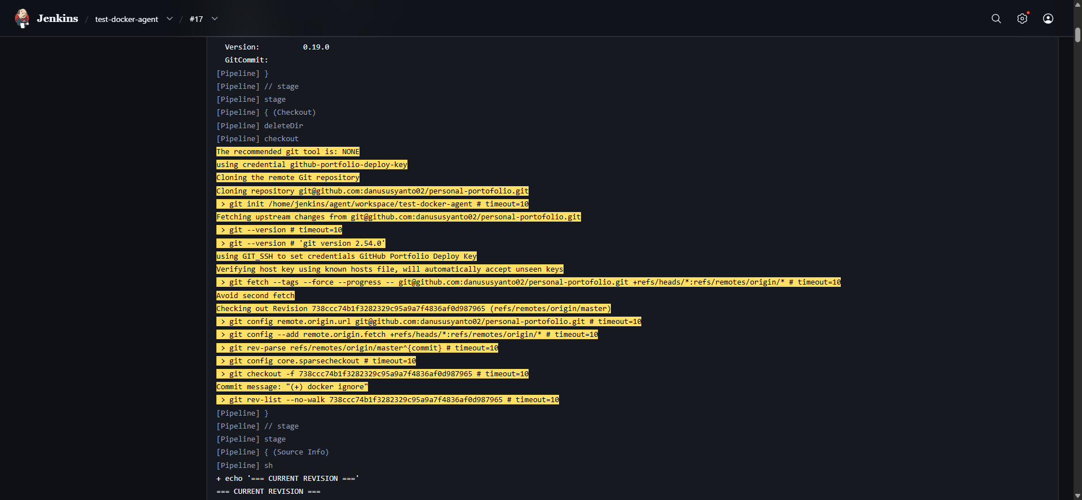
Figure 15. Jenkins Private Repository Checkout

Nuxt Container Build
- Nuxt application containerized with a multi-stage Dockerfile.
- Node 22 Alpine used for builder and runtime stages.
- npm ci used for deterministic installation from package-lock.json.
- Nuxt production build generated through npm run build.
- Only the .output directory copied into the runtime image.
- Runtime executed as the non-root node user.
- Application listens on port 3000 with the Nitro node-server preset.
- Images tagged with both Jenkins BUILD_NUMBER and latest.

Multi-stage Dockerfile
FROM node:22-alpine AS builder
WORKDIR /app
COPY package.json package-lock.json ./
RUN npm ci
COPY . .
RUN npm run build
FROM node:22-alpine AS runtime
WORKDIR /app
ENV NODE_ENV=production
ENV HOST=0.0.0.0
ENV PORT=3000
COPY --from=builder --chown=node:node /app/.output ./.output
USER node
EXPOSE 3000
CMD ["node", ".output/server/index.mjs"]

Image Versioning
danu-portfolio:11
danu-portfolio:12
danu-portfolio:13
...
danu-portfolio:<BUILD_NUMBER>
danu-portfolio:latest

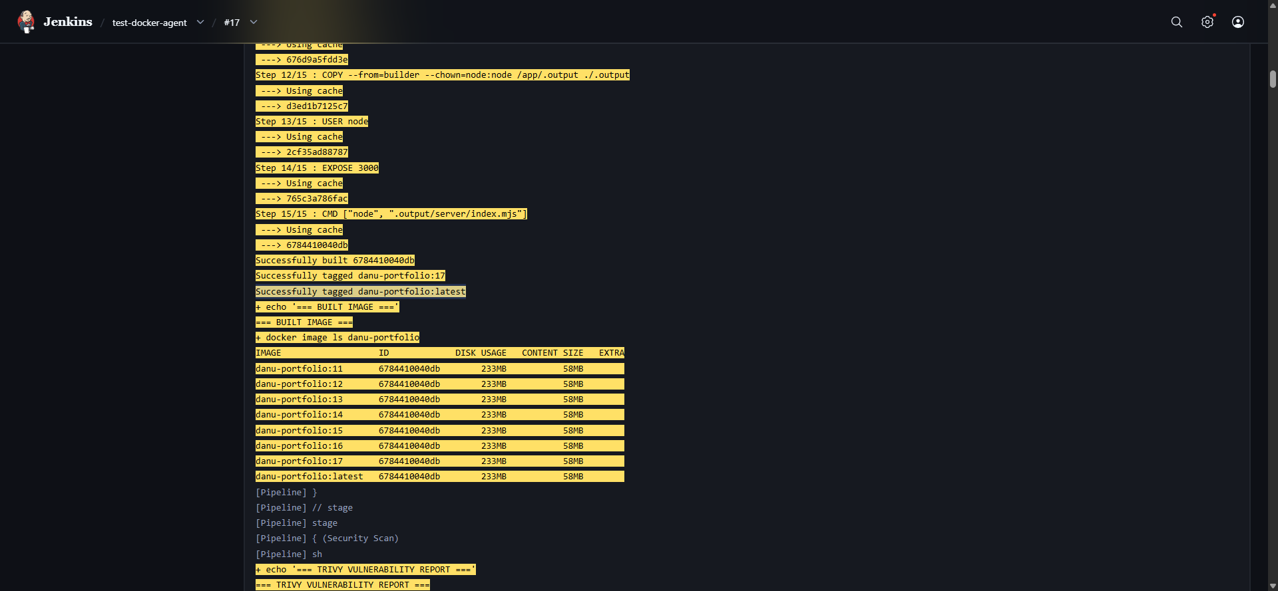
Figure 16. Successful Nuxt Docker Build

Trivy Vulnerability Scanning and Security Gate
- Trivy executed as a disposable Docker container from the Jenkins pipeline.
- Host Docker socket mounted read-only for local Docker image access.
- Persistent Trivy cache volume used for vulnerability database caching.
- HIGH and CRITICAL findings reported before deployment.
- A second CRITICAL-only scan configured with exit code 1 to act as a deployment security gate.
- Unfixed vulnerabilities ignored for gating through --ignore-unfixed.
- Initial scan detected two HIGH vulnerabilities and zero CRITICAL vulnerabilities.
- The HIGH findings were located in tooling bundled with the Node base image rather than the Nuxt application runtime dependency set.
Security Policy Applied
HIGH and CRITICAL vulnerabilities are reported for visibility. CRITICAL vulnerabilities block deployment. This provides a practical DevSecOps gate while keeping the home lab pipeline usable for iterative learning.
Finding | Severity | Installed | Fixed Version / Result
CVE-2026-33671 - picomatch | HIGH | 4.0.3 | 4.0.4 / 3.0.2 / 2.3.2
CVE-2026-48815 - sigstore | HIGH | 3.1.0 | 4.1.1
Critical gate result | CRITICAL | 0 findings | Deployment permitted

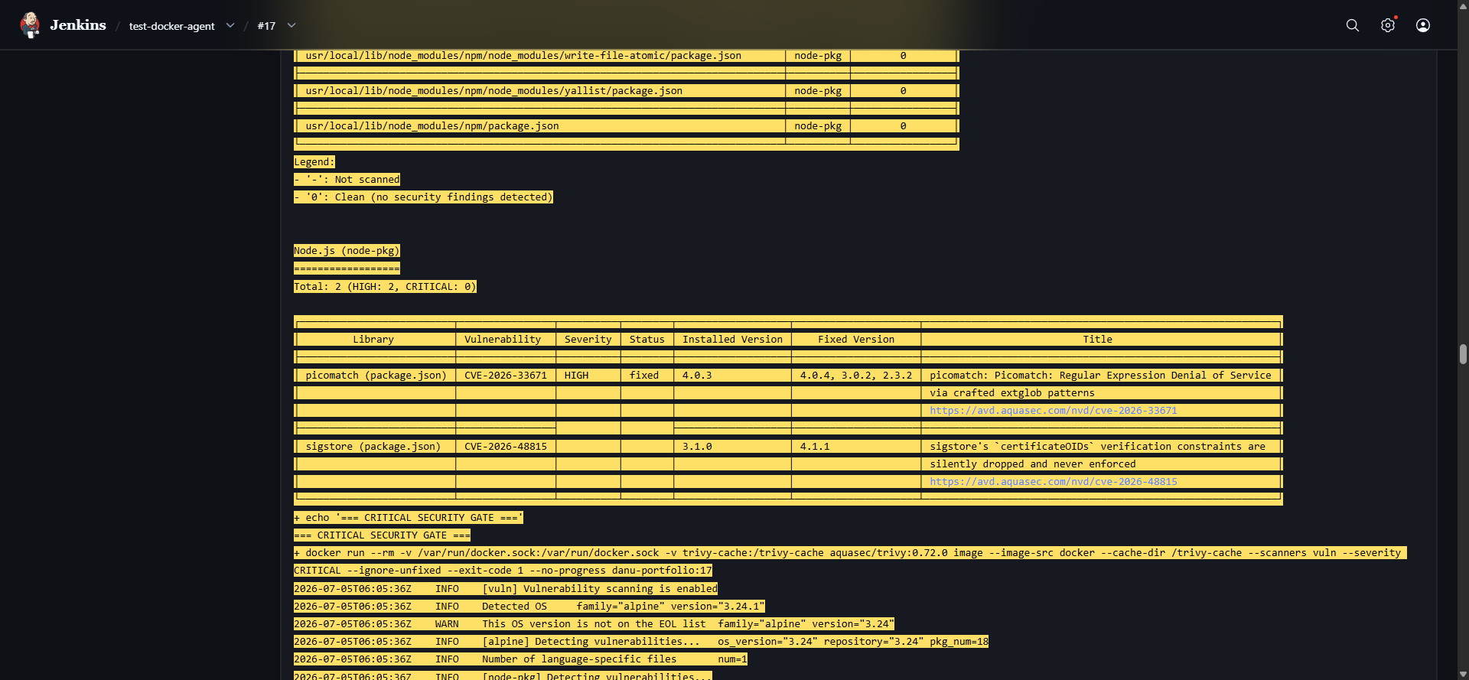
Figure 17. Trivy Vulnerability Report

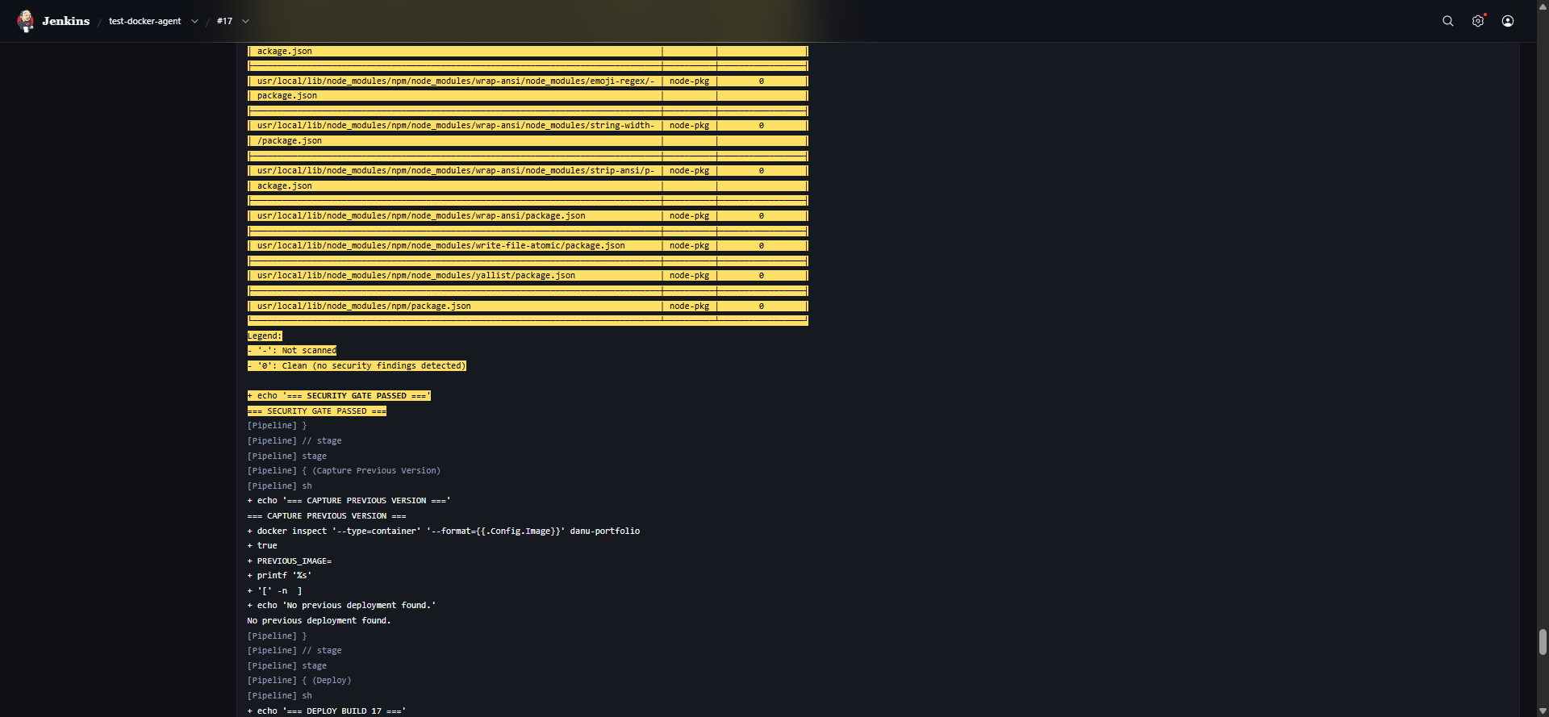
Figure 18. Critical Security Gate Passed

Automated Deployment and Application Health Check
- The current application container is replaced by the newly built versioned image.
- Container configured with restart policy unless-stopped.
- Port 3000 later restricted to host loopback: 127.0.0.1:3000:3000.
- Health check performed inside the application container using Node 22 global fetch.
- Health check retries up to 10 times with a 2-second delay.
- HTTP response must be successful before deployment is considered healthy.
- Container logs are printed when health validation fails.
Docker Build
↓
Trivy Security Scan
↓
Deploy Versioned Image
↓
Health Check (10 attempts)
├── HTTP 2xx → SUCCESS
└── Failure → Rollback path

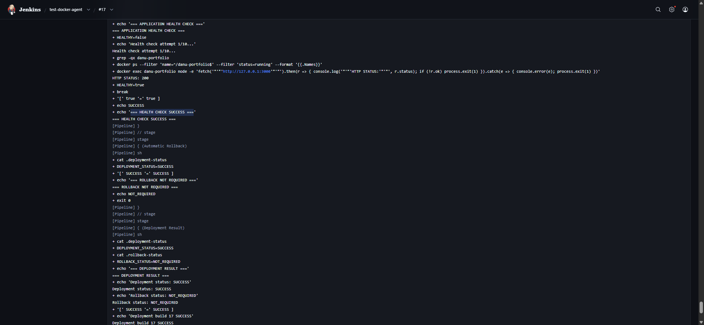
Figure 19. Automated Deployment and Health Check

Automatic Rollback and Production Recovery
- Previous production image captured from the currently running container before deployment.
- Previous image name stored as rollback metadata for the current pipeline execution.
- Failed deployments are identified through health-check status.
- Failed container removed automatically.
- Previous healthy image restarted using the same container name, restart policy, and loopback port binding.
- Rollback target receives a separate rollback health check.
- Pipeline remains FAILURE when the new release fails, even if rollback succeeds.
- Failure simulation parameter added to prove the recovery logic without deliberately breaking application source code.
Healthy Production :14
↓
Deploy :15
↓
Simulated Failure
↓
Health Check FAILED
↓
AUTOMATIC ROLLBACK STARTED
↓
Restore :14
↓
Rollback Health Check HTTP 200
↓
ROLLBACK SUCCESS
↓
Pipeline FAILURE / Production Restored
Validation Result
The rollback test successfully restored danu-portfolio:14 after the simulated deployment of build :15 failed. Jenkins correctly marked the new release as failed while restoring the previous production version.

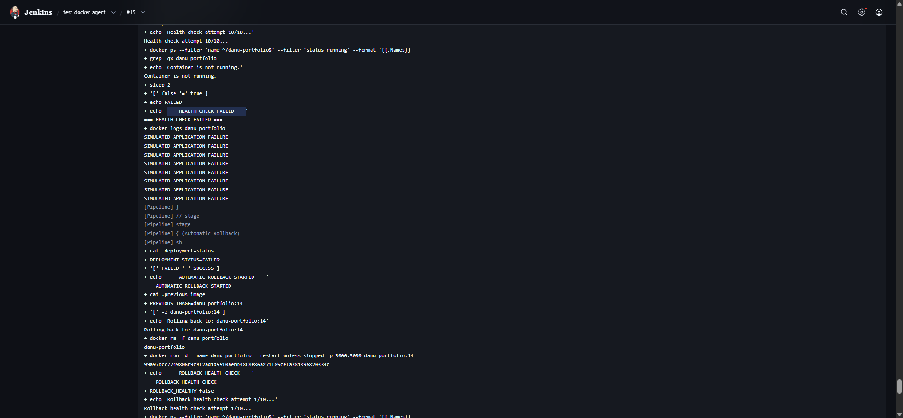
Figure 20. Automatic Rollback Started

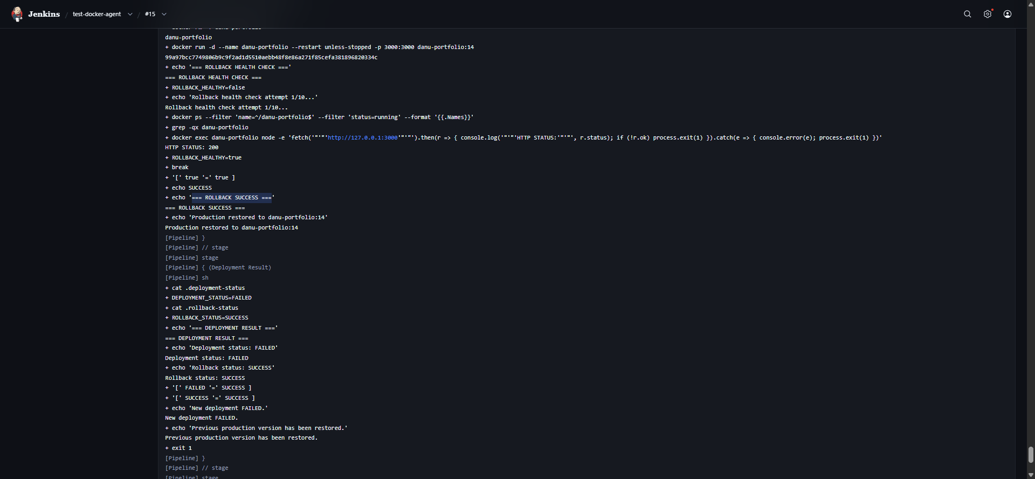
Figure 21. Rollback Success and Production Restored

Nginx Reverse Proxy and Backend Isolation
- Nginx installed natively on the Ubuntu CI/CD server.
- Custom site configuration created for the portfolio application.
- Nginx listens on TCP port 80 and proxies traffic to 127.0.0.1:3000.
- Host, X-Real-IP, X-Forwarded-For, and X-Forwarded-Proto headers forwarded to the backend.
- Default Nginx site disabled.
- Configuration validated with nginx -t before reload.
- Jenkins deployment changed from 0.0.0.0:3000 exposure to 127.0.0.1:3000 binding.
- All normal deploy, simulated failure, and rollback paths use the loopback-only port binding.
Client
↓
http://192.168.88.40 :80
↓
Nginx Reverse Proxy
↓
127.0.0.1:3000
↓
Nuxt Container
Access Path | Result
http://192.168.88.40 | Accessible through Nginx
http://192.168.88.40:3000 | Not directly exposed to LAN
http://127.0.0.1:3000 on Ubuntu host | Backend reachable locally

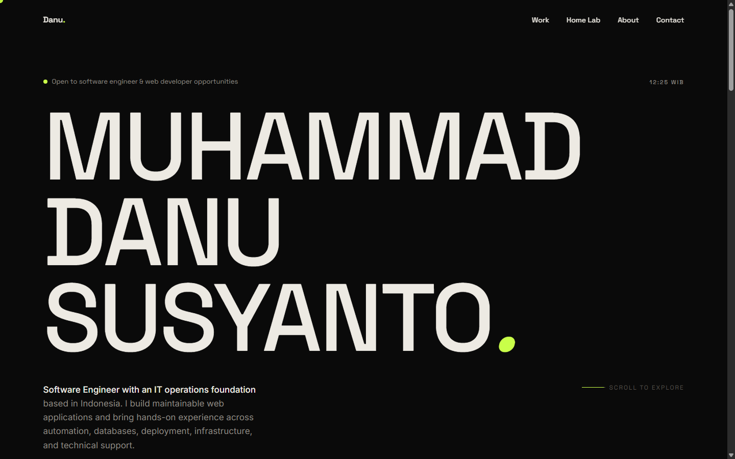
Figure 22. Nginx Reverse Proxy Validation

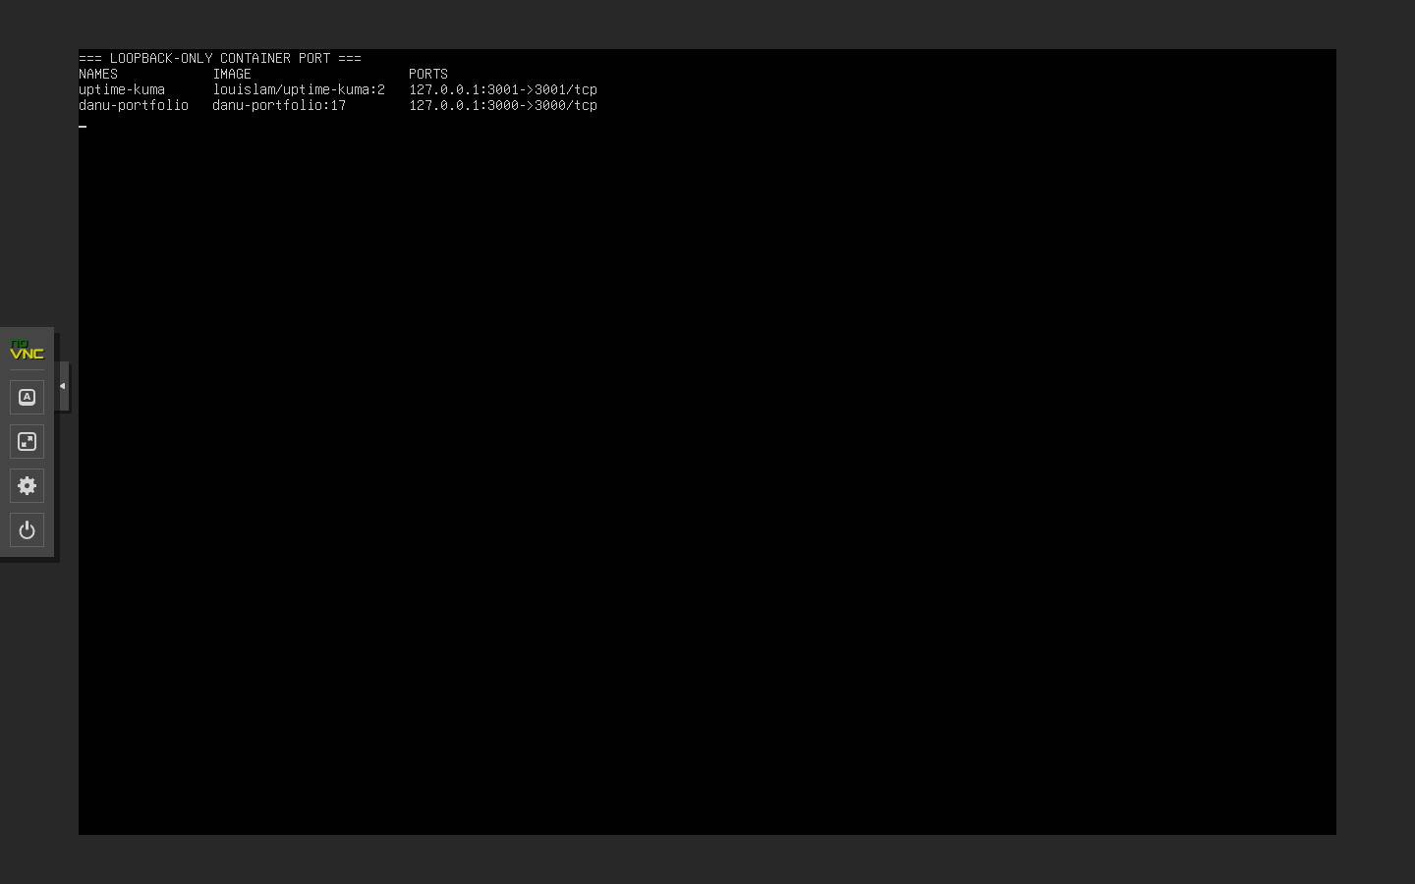
Figure 23. Loopback-Only Container Port

Internal DNS and Uptime Kuma Monitoring
- Uptime Kuma deployed as a Docker container with restart policy unless-stopped.
- Uptime Kuma port 3001 bound to host loopback only: 127.0.0.1:3001.
- Persistent Docker volume uptime-kuma-data mounted to /app/data.
- Nginx reverse proxy site configured for status.danu-lab.local.
- WebSocket upgrade headers forwarded through Nginx.
- A Host (A) record created in Windows DNS: status.danu-lab.local → 192.168.88.40.
- PC DNS resolver corrected to use the Windows DNS server at 192.168.88.20 for internal zone resolution.
- Uptime Kuma configured with SQLite for a simple single-instance home lab deployment.
- HTTP monitor created for Danu Portfolio using http://192.168.88.40.
- Heartbeat interval configured to 60 seconds.
- Monitor validated in UP state with 100% initial uptime and measured response time.
status.danu-lab.local
↓ DNS A record
192.168.88.40
↓
Nginx :80
↓
127.0.0.1:3001
↓
Uptime Kuma
↓ monitor every 60 sec
http://192.168.88.40
↓
Nginx → Nuxt

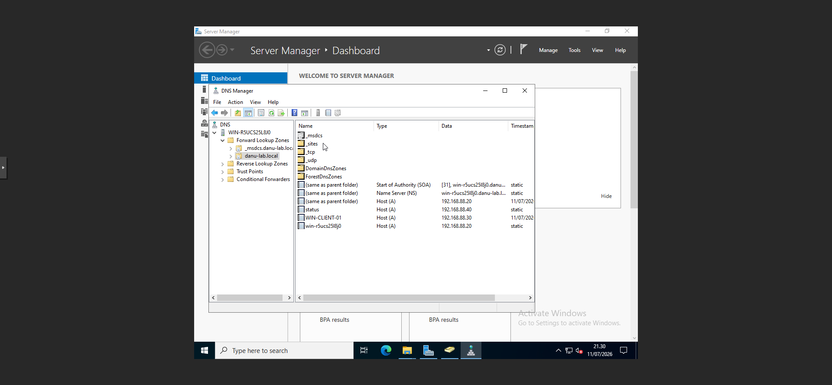
Figure 24. Windows DNS A Record for Uptime Kuma

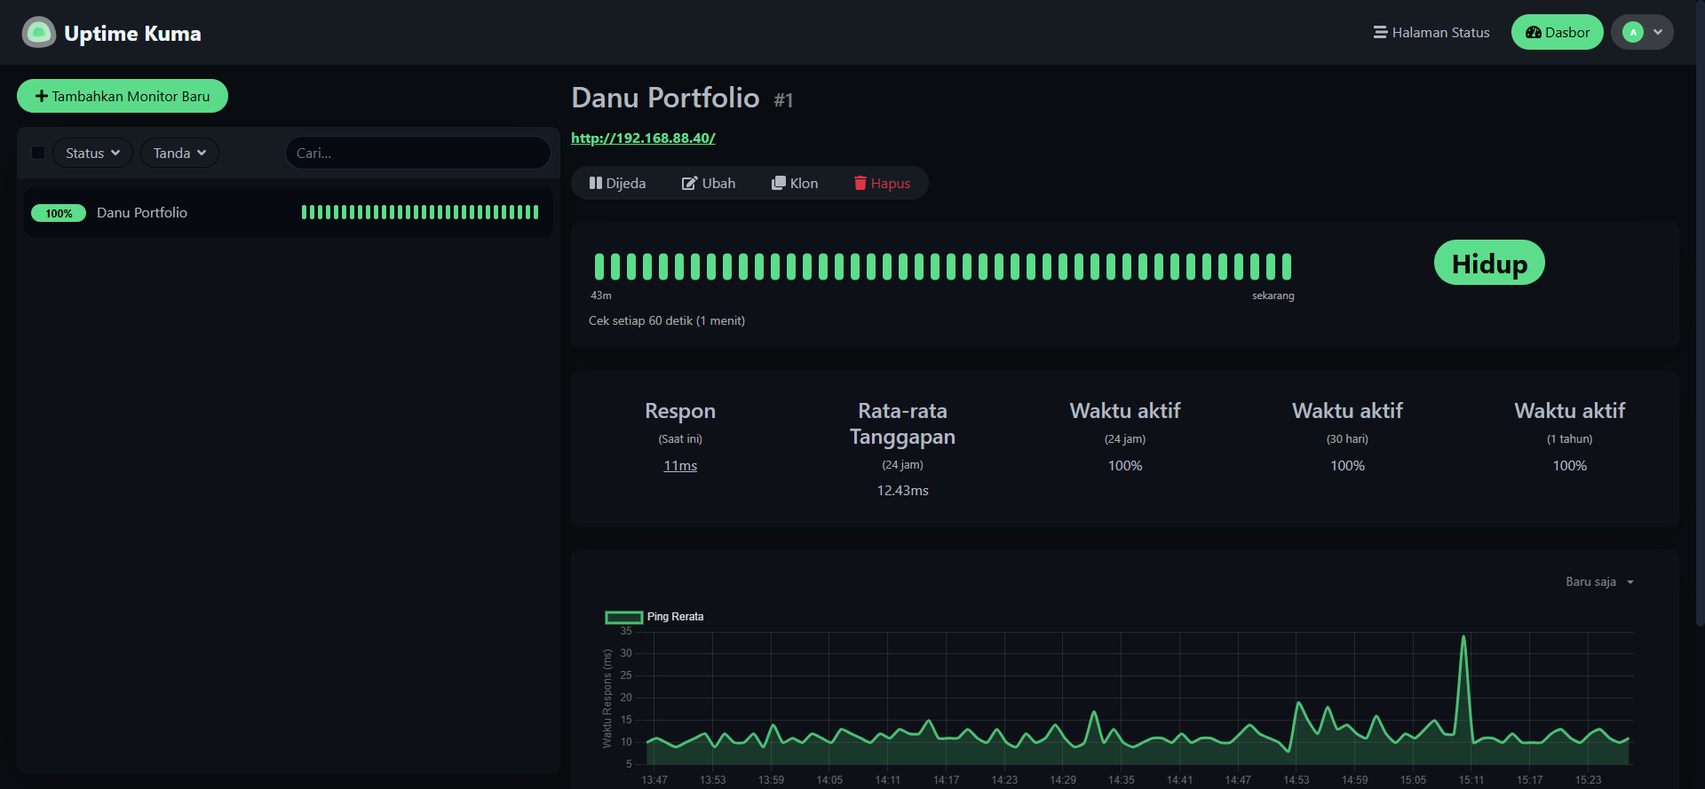
Figure 25. Uptime Kuma Dashboard - Portfolio Up

Final Jenkins Pipeline Capabilities
Capability | Implementation
Source Control | Private GitHub repository checkout over SSH
Build Isolation | Dynamic disposable Jenkins Docker agent
Build | Nuxt multi-stage Docker image build
Versioning | Image tagged with Jenkins BUILD_NUMBER and latest
Security | Trivy HIGH/CRITICAL report and CRITICAL security gate
Deployment | Automated Docker container replacement
Validation | 10-attempt application health check
Recovery | Automatic rollback to previous healthy image
Network Entry | Nginx reverse proxy on port 80
Backend Isolation | Nuxt bound to 127.0.0.1:3000 only
Service Discovery | Windows DNS for status.danu-lab.local
Monitoring | Uptime Kuma HTTP monitor every 60 seconds

Current Delivery Flow
Checkout
↓
Source Info
↓
Docker Build
↓
Trivy Vulnerability Report
↓
CRITICAL Security Gate
↓
Capture Previous Version
↓
Deploy
↓
Application Health Check
↓
Automatic Rollback if Required
↓
Deployment Result

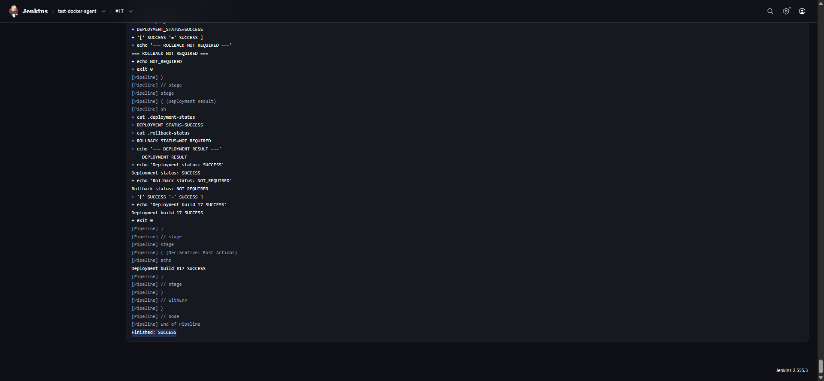
Figure 26. Jenkins Pipeline Stage View or Console Summary

PORTFOLIO SUMMARY

Consolidated Implementation Matrix
Project | Area | Implementation | Status
01 | AD DS | Domain controller, danu-lab.local, centralized identity | Validated
01 | DNS | Internal AD-integrated DNS and domain resolution | Validated
01 | Identity | OUs, departmental users, global security groups | Validated
02 | Endpoint | Windows 10 Pro domain join and domain login | Validated
03 | File Server | Finance, HR, IT, Public SMB shares | Validated
03 | Access Control | NTFS ACLs using AD security groups | Validated
04 | CI/CD | Jenkins automated build and deployment | Validated
04 | Docker | Multi-stage build, image versioning, runtime container | Validated
04 | Dynamic Agents | Disposable Jenkins Docker agents | Validated
04 | DevSecOps | Trivy report and CRITICAL deployment gate | Validated
04 | Resilience | Automatic rollback and rollback health check | Validated
04 | Reverse Proxy | Nginx entry point with loopback-only backend | Validated
04 | Internal DNS | status.danu-lab.local A record | Validated
04 | Monitoring | Uptime Kuma HTTP heartbeat every 60 seconds | Validated

Skills Demonstrated Across Projects 01-04

Windows Infrastructure
- Windows Server 2022 administration
- Active Directory Domain Services
- DNS services
- Windows 10 domain client administration
- SMB file sharing and NTFS permissions

Identity and Access Management
- OU design
- User and group administration
- Department-based authorization
- Least-privilege access testing

Linux and Platform Operations
- Ubuntu Server administration
- systemd service validation
- LVM disk expansion
- SSH administration
- Nginx configuration

CI/CD and Automation
- Jenkins pipeline design
- Private Git checkout over SSH
- Dynamic disposable agents
- Automated build, deploy, health check, and rollback

Containers and Security
- Docker image build and runtime
- Multi-stage Dockerfiles
- Versioned image strategy
- Docker socket integration
- Trivy vulnerability scanning and CI security gating

Monitoring and Troubleshooting
- Uptime Kuma service monitoring
- HTTP endpoint validation
- DNS troubleshooting
- Permission and access testing
- Failure simulation and production recovery validation

Key Engineering and Operational Decisions
Decision | Reason
Use AD groups for file authorization | Permissions remain manageable and department membership controls access without assigning individual user ACLs.
Use dynamic Jenkins agents | Build workloads are isolated from the controller and disposable agent containers are removed after completion.
Version images by Jenkins build number | Each deployment has a traceable image tag and the previous healthy version can be restarted during rollback.
Block only CRITICAL vulnerabilities initially | The pipeline provides a meaningful security gate while HIGH findings remain visible for remediation and learning.
Keep pipeline FAILURE after successful rollback | The failed release remains correctly classified as failed even though production service is recovered.
Bind Nuxt to host loopback | The application backend is not directly exposed to the LAN; Nginx is the primary entry point.
Monitor the Nginx-to-Nuxt path | Uptime Kuma validates the same HTTP entry path used by clients rather than checking only the internal application process.

Future Improvement Opportunities
The following items are deliberately outside the completed scope of Projects 01-04. They can be implemented as separate future projects rather than expanding the current portfolio project indefinitely.
Opportunity | Possible Next Step
HTTPS / Internal PKI | Add TLS termination in Nginx and use an internal CA or a trusted certificate strategy.
Blue-Green Deployment | Deploy a candidate container on a separate port, validate it, then switch Nginx upstream to reduce deployment downtime.
BuildKit / Buildx | Replace the legacy Docker builder and adopt modern Docker build workflow.
Pipeline as Code | Move the Jenkins pipeline into a Jenkinsfile stored in the Git repository.
Notifications | Send Uptime Kuma or Jenkins failure notifications to email, Discord, or another supported channel.
Metrics and Logging | Add Prometheus/Grafana or centralized logging as a separate observability project.
Infrastructure Automation | Use Ansible or Terraform for repeatable infrastructure configuration in a dedicated project.

Conclusion
Projects 01 through 04 form a connected home lab portfolio that progresses from foundational Windows infrastructure to an automated and monitored application delivery environment. The work demonstrates practical configuration, troubleshooting, security, validation, and recovery rather than isolated software installation.
The final environment combines centralized identity, domain client integration, group-based file access control, Jenkins CI/CD automation, disposable build agents, container versioning, vulnerability scanning, automatic rollback, reverse proxying, internal DNS, and continuous HTTP monitoring. Together, these implementations provide strong evidence for IT Infrastructure, IT Support, and DevOps-lite portfolio positioning.
Final Project Status
Projects 01-04 are implemented and validated. Screenshot placeholders in this document are intentionally provided so project evidence can be inserted before portfolio publication.

Screenshot Evidence Checklist
No. | Screenshot / Evidence
01 | Proxmox Home Lab Overview
02 | Active Directory Domain and OU Structure
03 | AD Users and Security Groups
04 | Project 01 Validation
05 | WIN-CLIENT-01 Domain Membership
06 | Domain User Login Validation
07 | Windows Client in Active Directory
08 | Department Share Folder Structure
09 | Finance NTFS Permissions
10 | Authorized Access Test
11 | Unauthorized Access Denied Test
12 | UBUNTU-CICD-01 VM and Network
13 | Jenkins Docker Cloud and Agent Template
14 | Disposable Docker Agent Validation
15 | Jenkins Private Repository Checkout
16 | Successful Nuxt Docker Build
17 | Trivy Vulnerability Report
18 | Critical Security Gate Passed
19 | Automated Deployment and Health Check
20 | Automatic Rollback Started
21 | Rollback Success and Production Restored
22 | Nginx Reverse Proxy Validation
23 | Loopback-Only Container Port
24 | Windows DNS A Record for Uptime Kuma
25 | Uptime Kuma Dashboard - Portfolio Up
26 | Jenkins Pipeline Stage View or Console Summary

